**Importing the Libraries:**

import numpy as np

import matplotlib.pyplot as plt

import pandas as pd

import seaborn as sns

from sklearn.metrics import r2_score

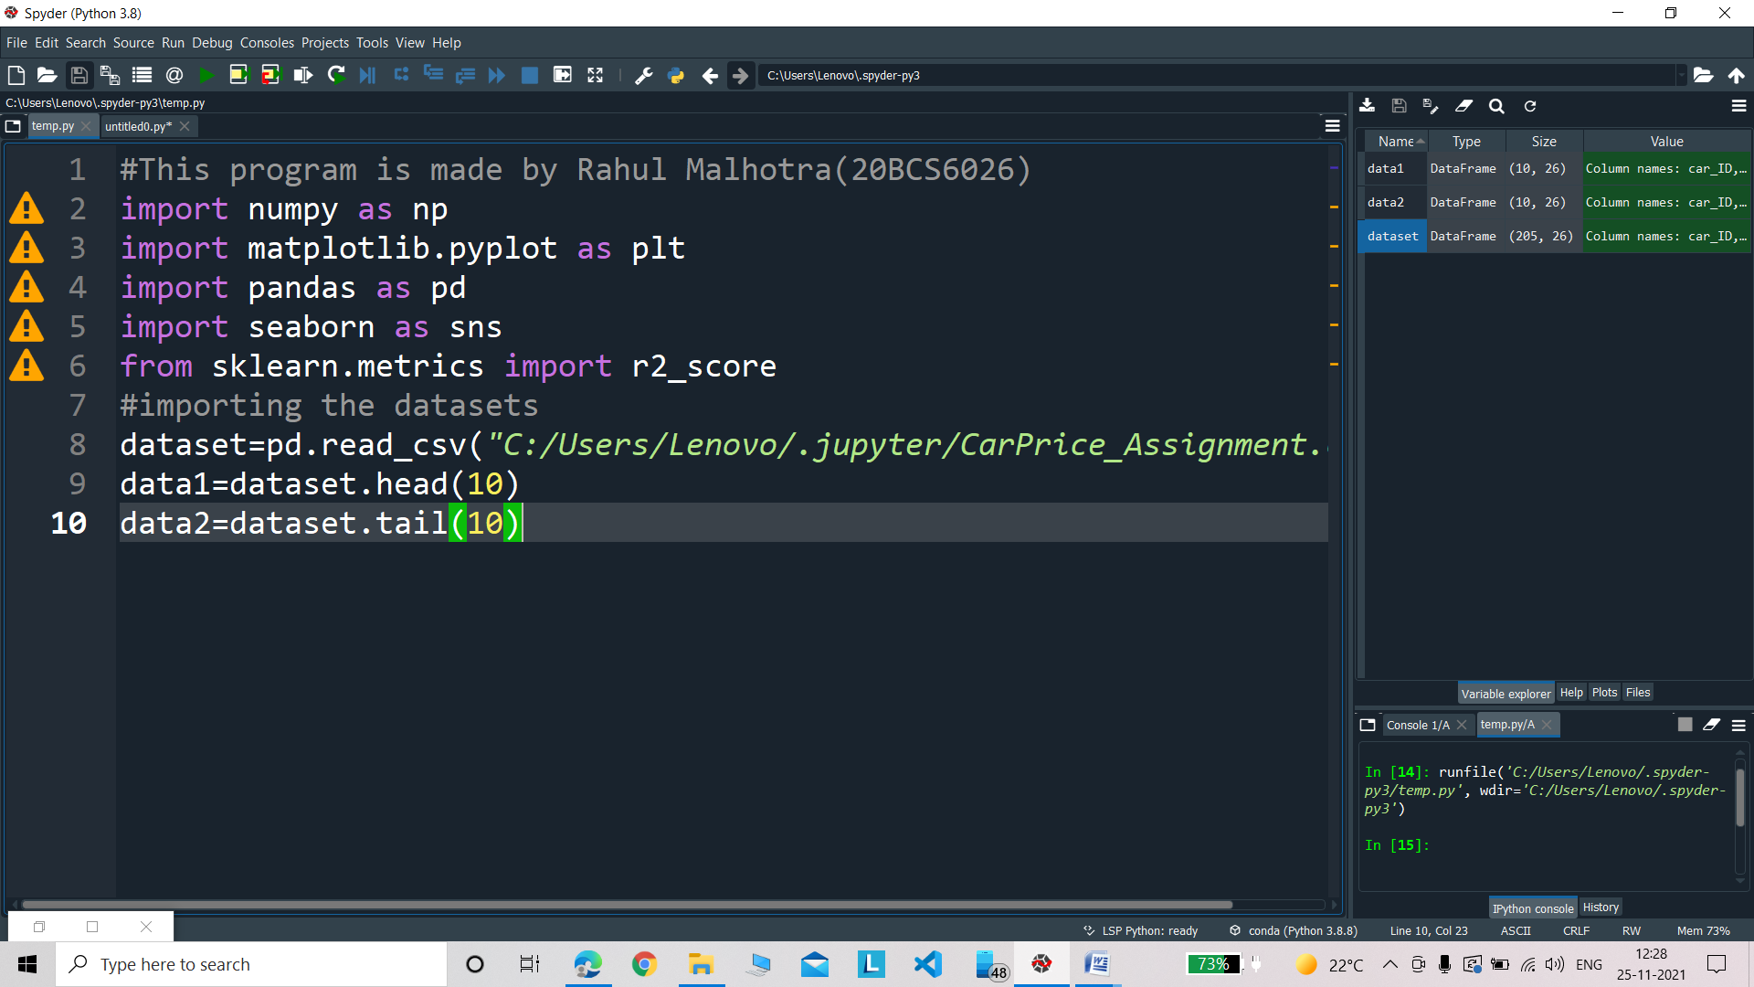

**Importing the datasets**

#importing the datasets

dataset=pd.read_csv("C:/Users/Lenovo/.jupyter/CarPrice_Assignment.csv")

data1=dataset.head(10)

data2=dataset.tail(10)



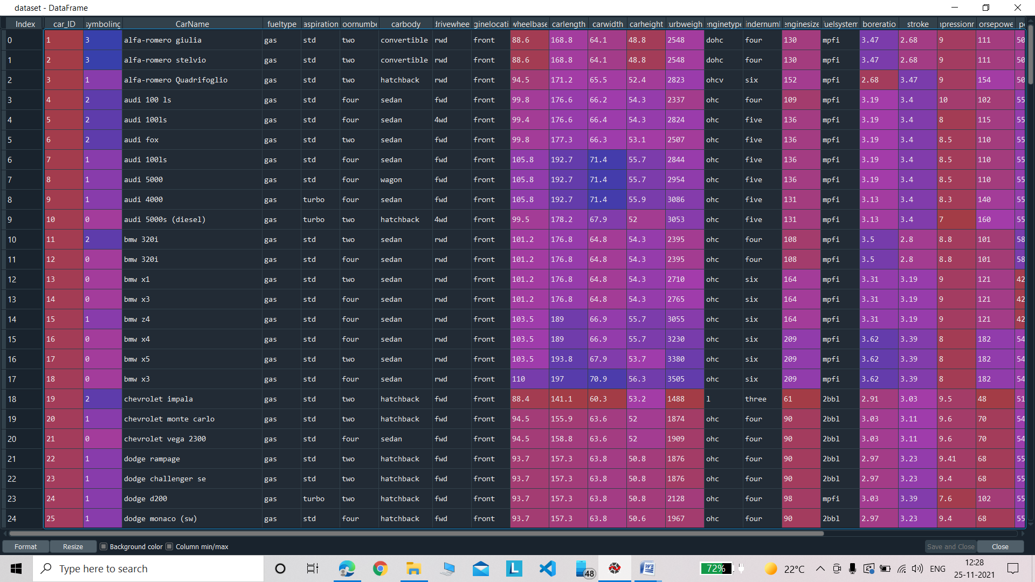

**Analysing the first and last values of the dataset:**

data1=dataset.head(10)

data2=dataset.tail(10)

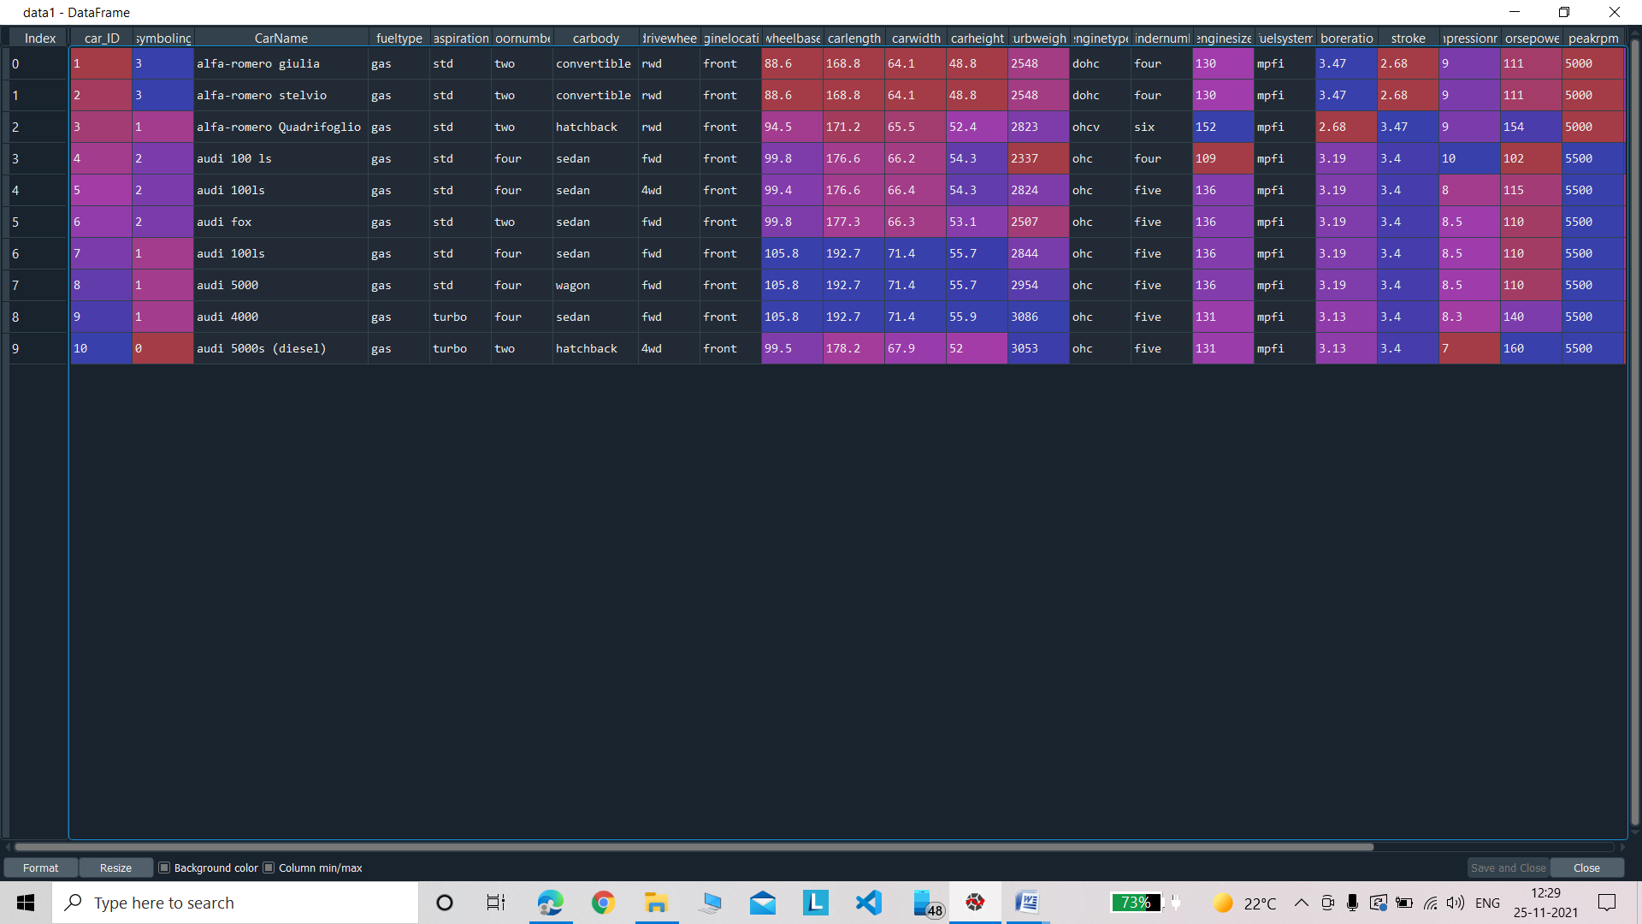

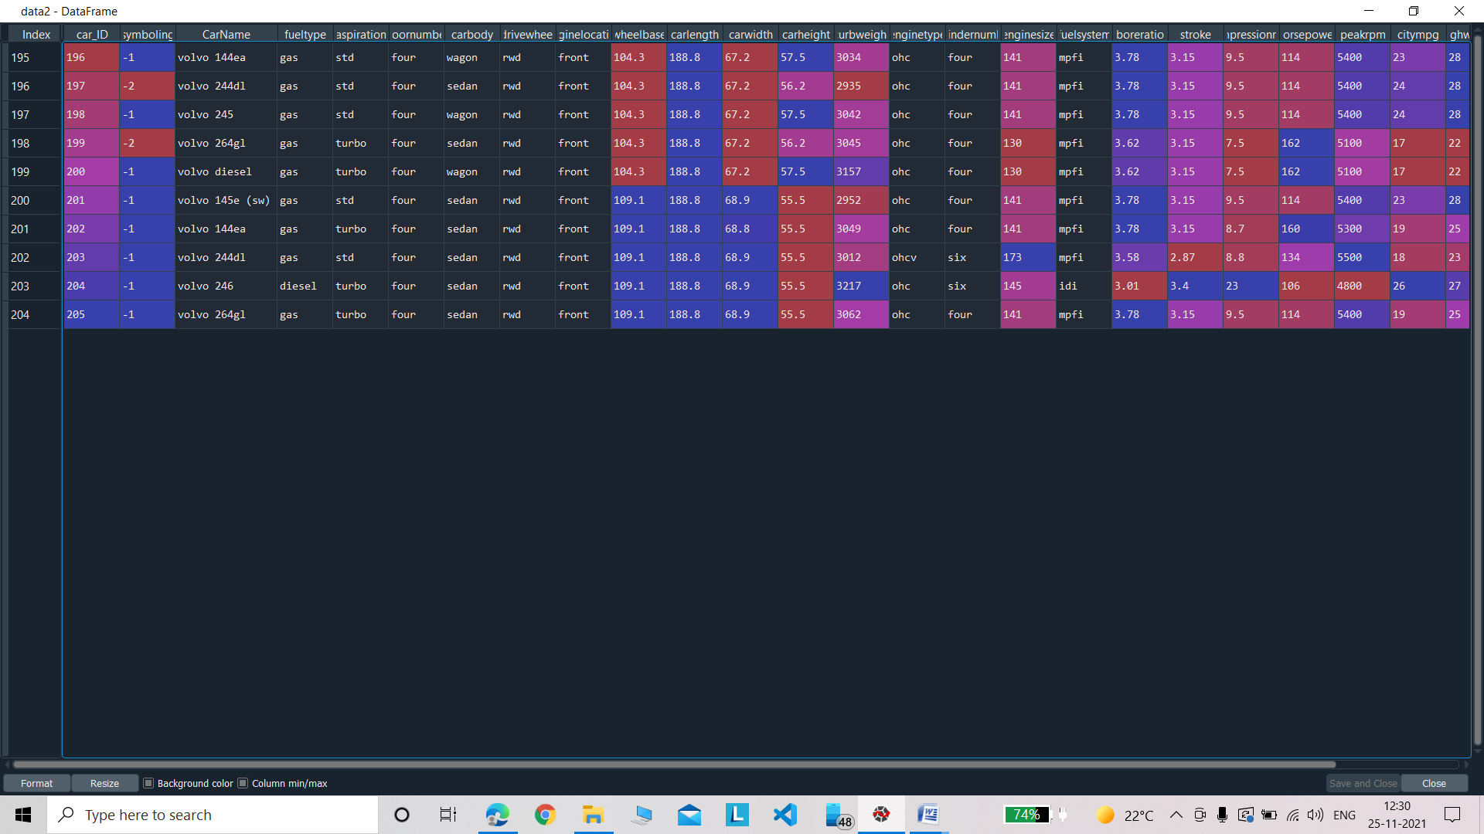

**Dropping the duplicate and null values of the dataset:**

#dropping the duplicates

dataset = dataset.drop_duplicates()

#dropping the Null Values

dataset = dataset.dropna()

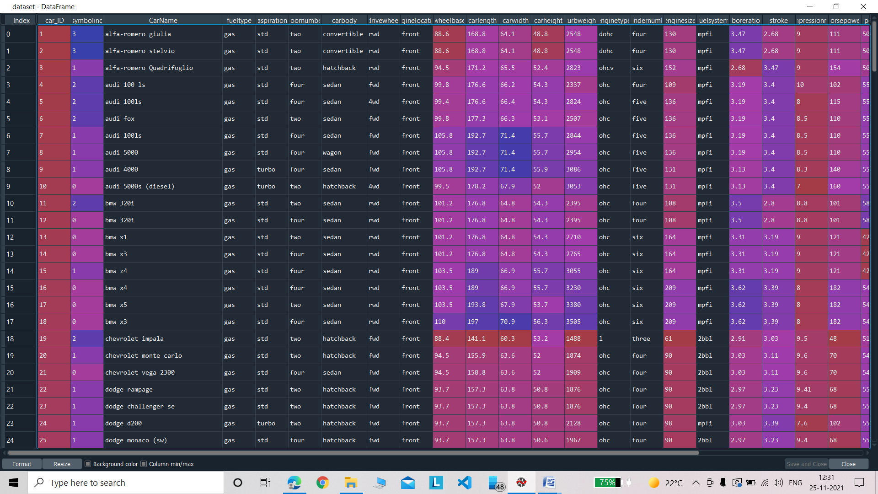

**Dropping** **the non important independent variables:**

#dropping the non important independent variables

dataset = dataset.drop(['CarName', 'fueltype', 'aspiration', 'doornumber', 'carbody', 'drivewheel','enginelocation','enginetype','cylindernumber','fuelsystem'], axis=1

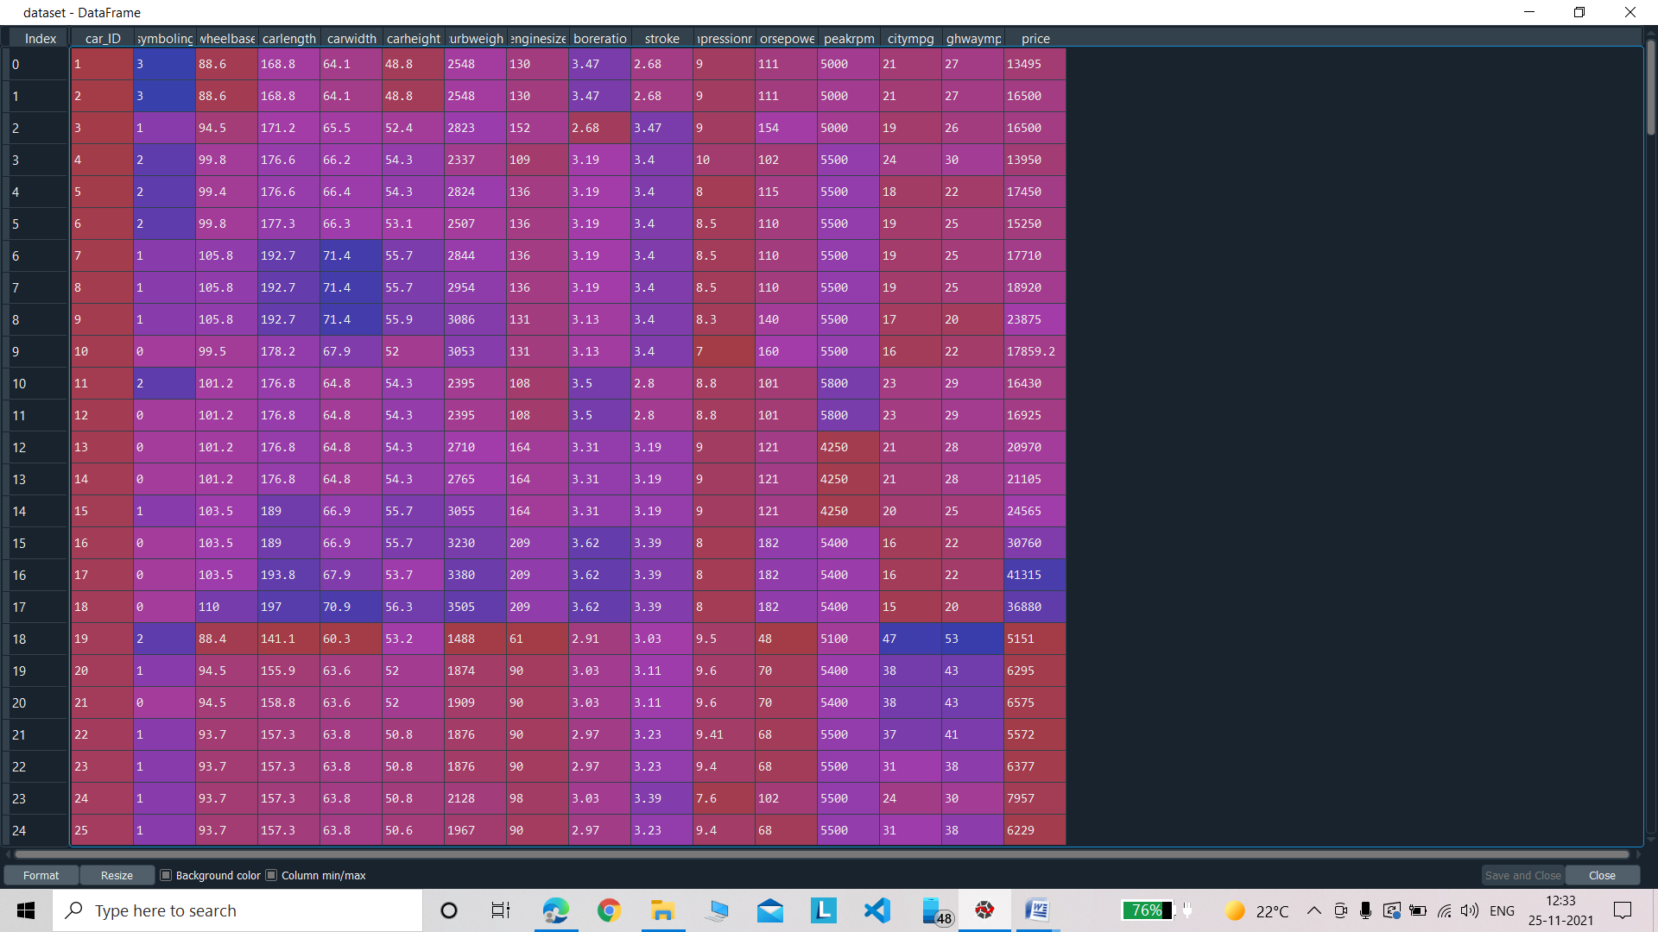

**Analyzing the dataset visually:**

**Drawing the countplot:**

#analyzing the dataset visually

#drawing the countplot

sns.countplot(x="carlength", data=dataset)

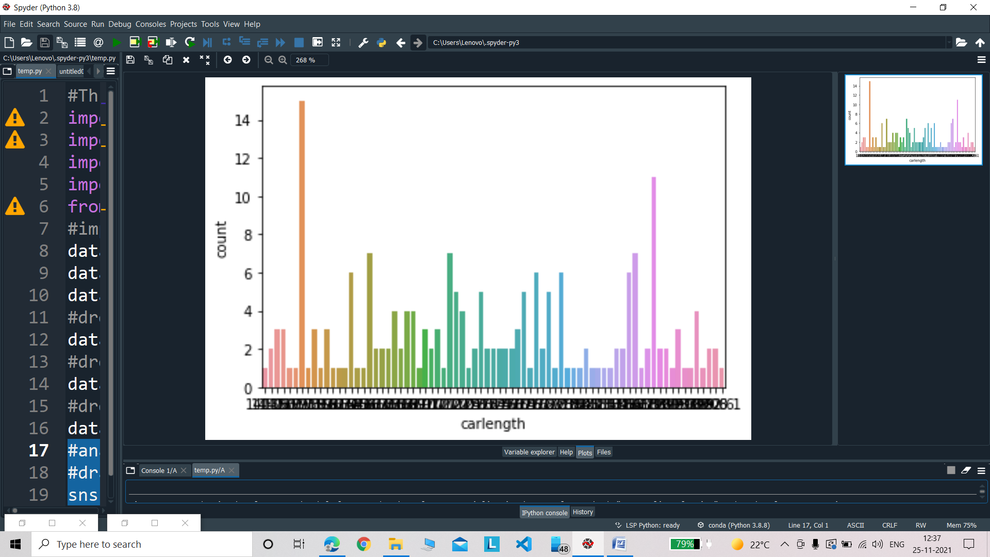

**Plotting the Histogram:**

#Plotting the Histogram

dataset["carlength"].plot.hist()

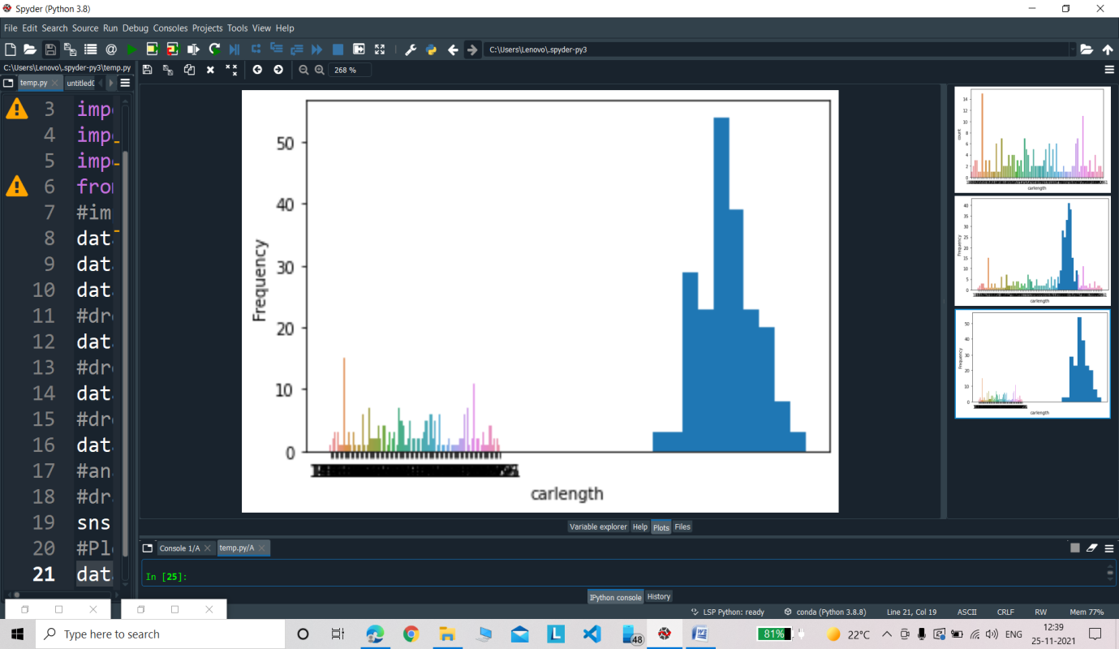

**Plotting the Heatmap:**

#Plotting the Heatmap

#sns.heatmap(dataset.isnull())

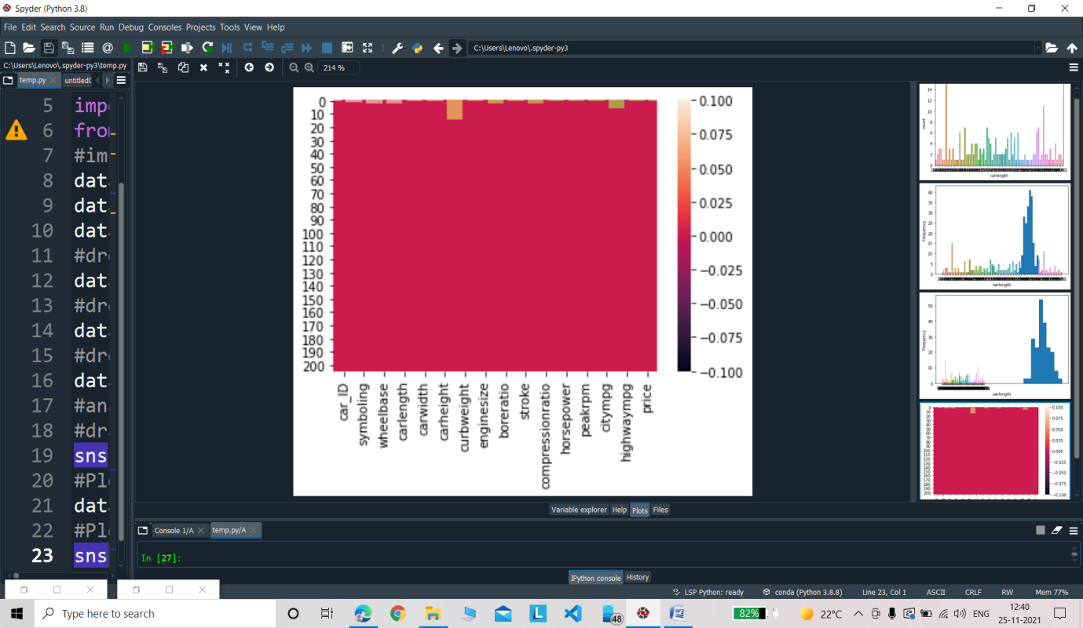

**Seperate the dependet and the independent variables**

#seperate the dependet and the independent variables

X=dataset.iloc[:,:-1].values

Y=dataset.iloc[:,-1].values

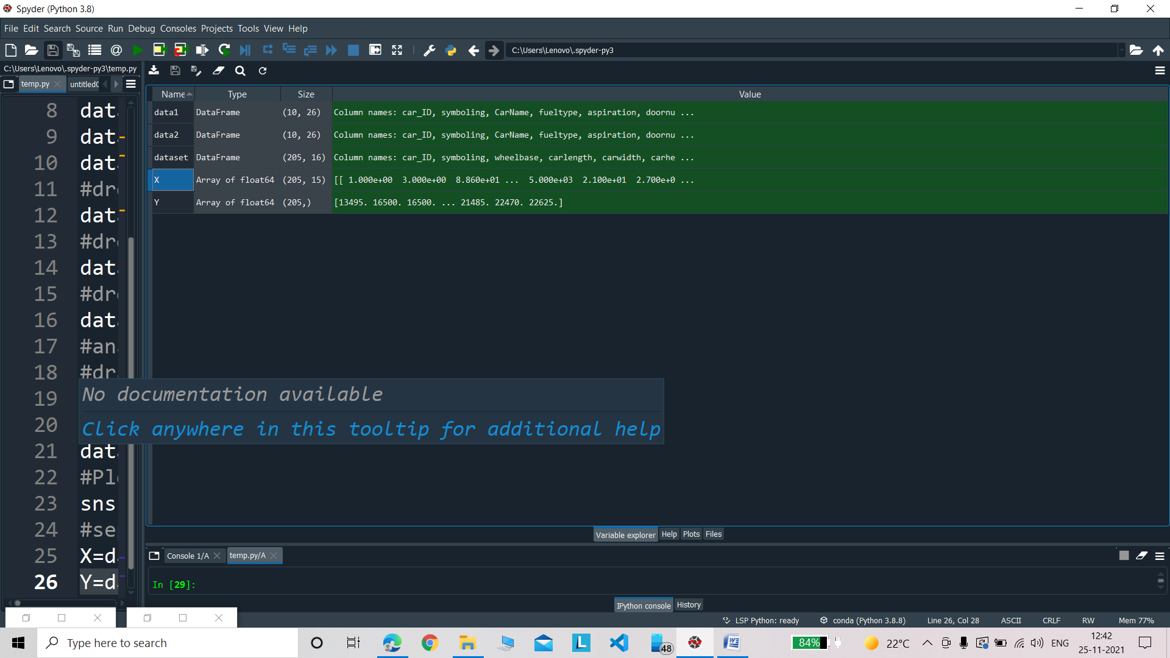

**Independent Variables:**

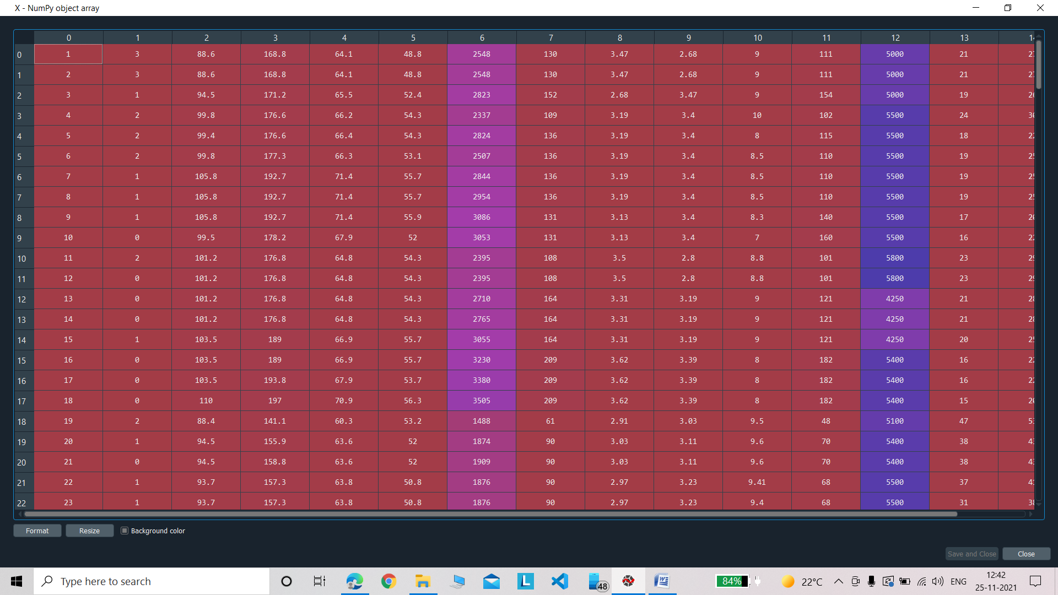

**Dependent Variables:**

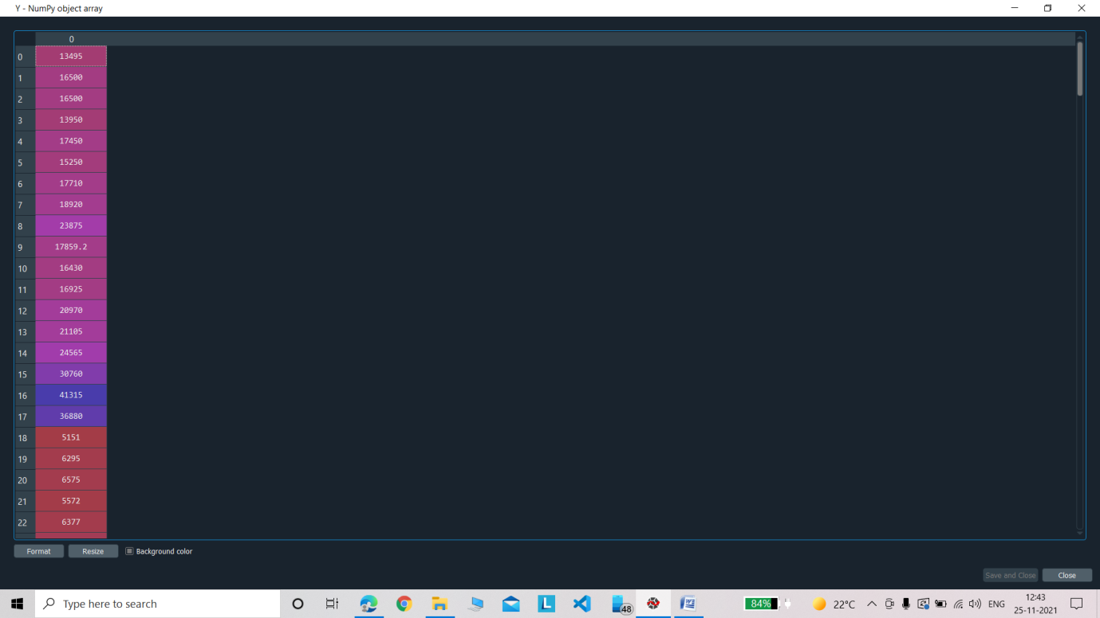

**Dividing the datasets into training and testing**

#dividing the datasets into training and testing

from sklearn.model_selection import train_test_split

X_train, X_test, Y_train, Y_test=train_test_split(X,Y, test_size=1/3)

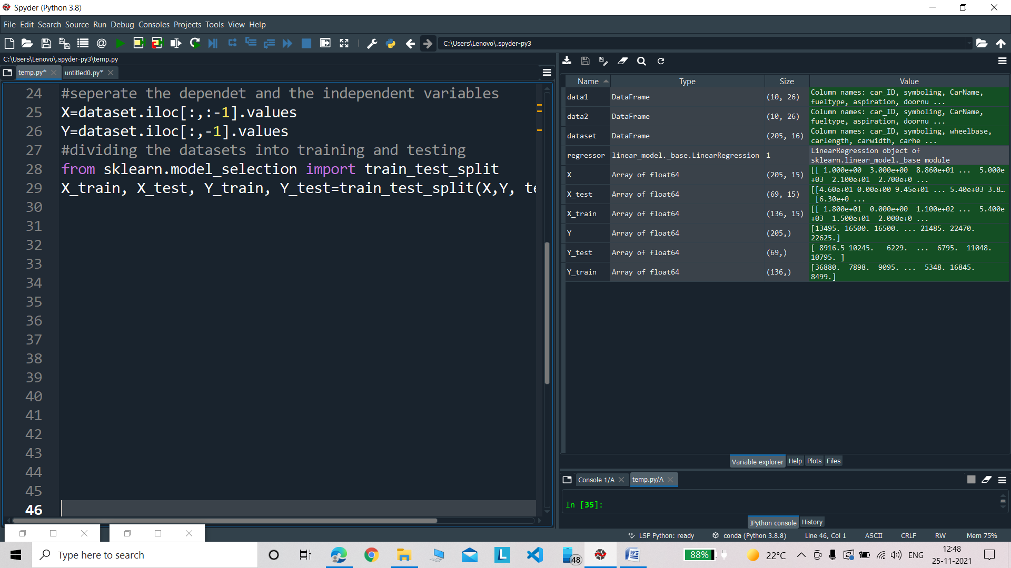

**Training Dataset:**

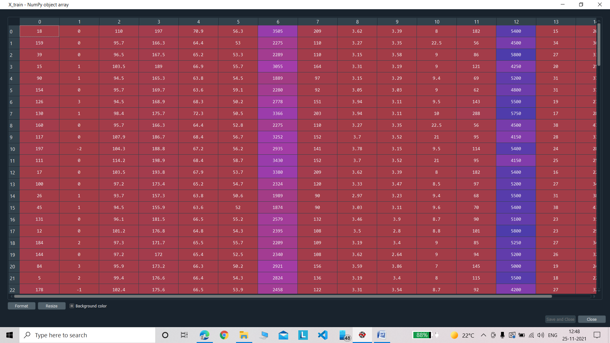

**Testing Dataset:**

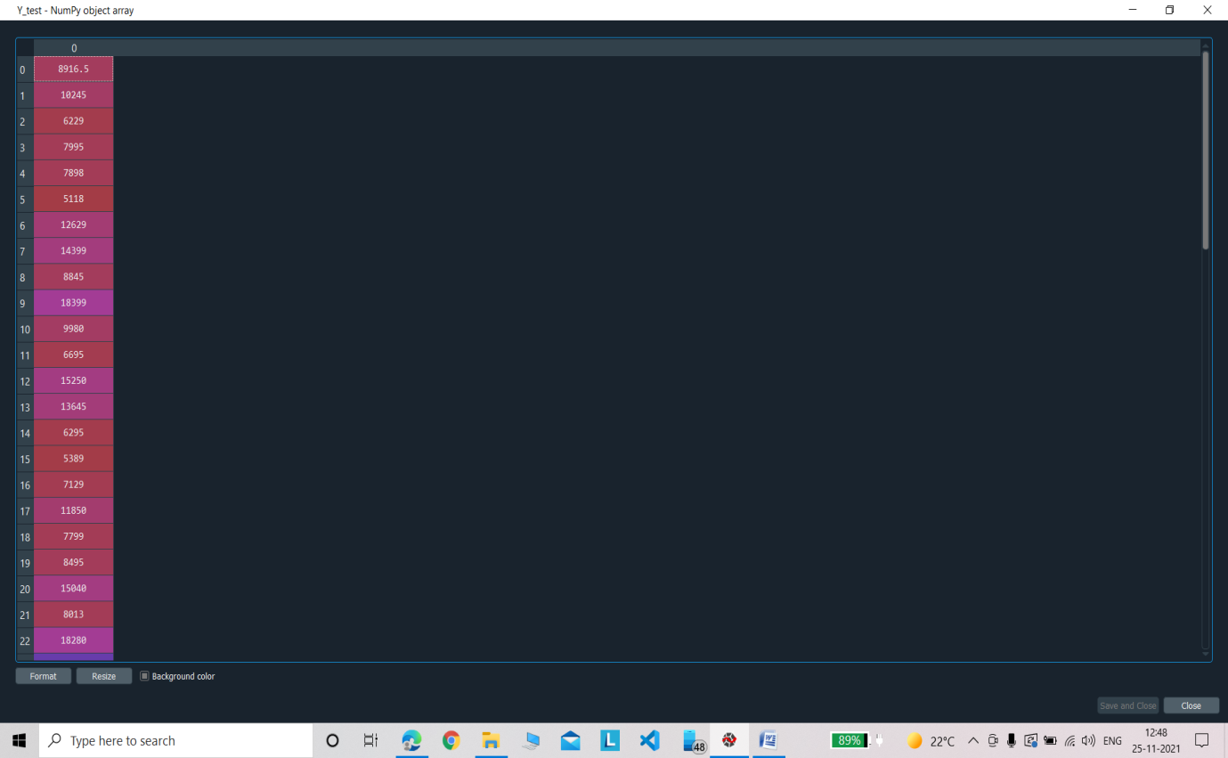

**Training the linear regression machine learning model using the training dataset**

#training the linear regression machine learning model using the training dataset

from sklearn.linear_model import LinearRegression

regressor = LinearRegression()

regressor.fit(X_train, Y_train)

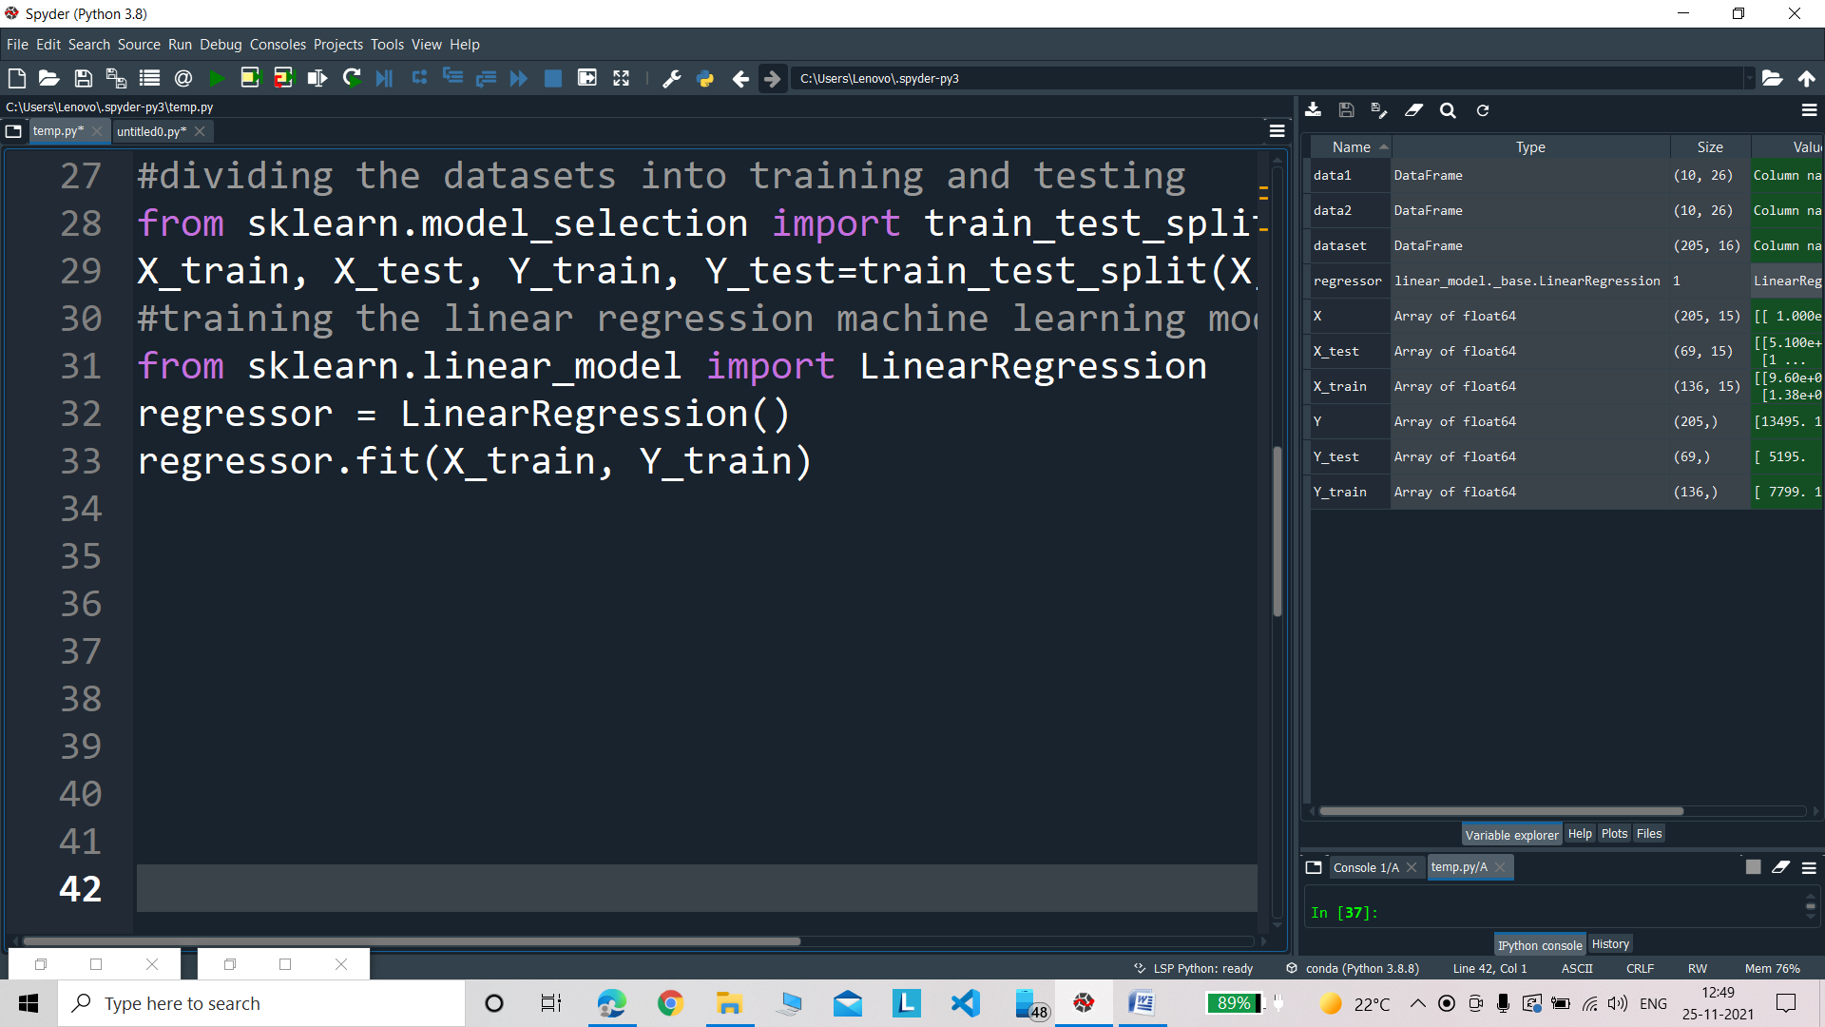

**Predicting the results for the testing datasets:**

#now predicting the results for the testing datasets

Y_pred=regressor.predict(X_test)

**Predicted Values:**

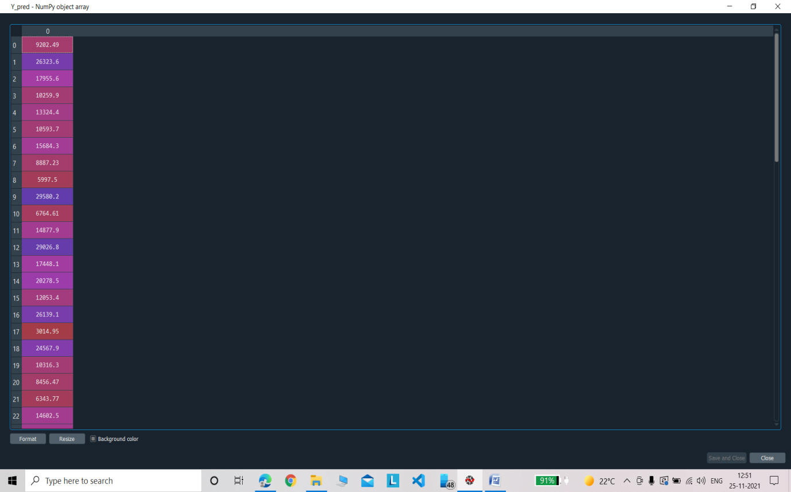

**Testing Values:**

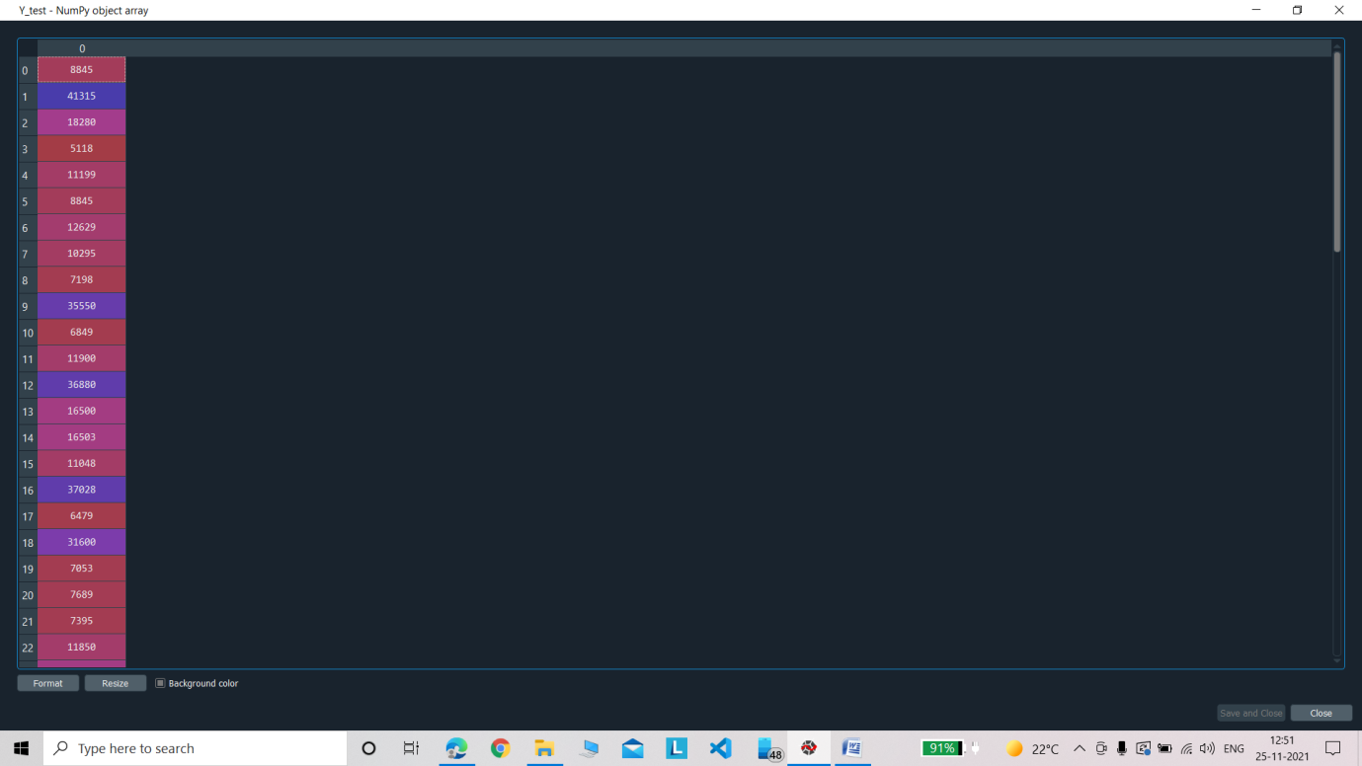

**Testing** **the accuray of the model using accuracy**

#testing the accuray of the model using accuracy

from sklearn.metrics import mean_squared_error

r2_score=regressor.score(X,Y)

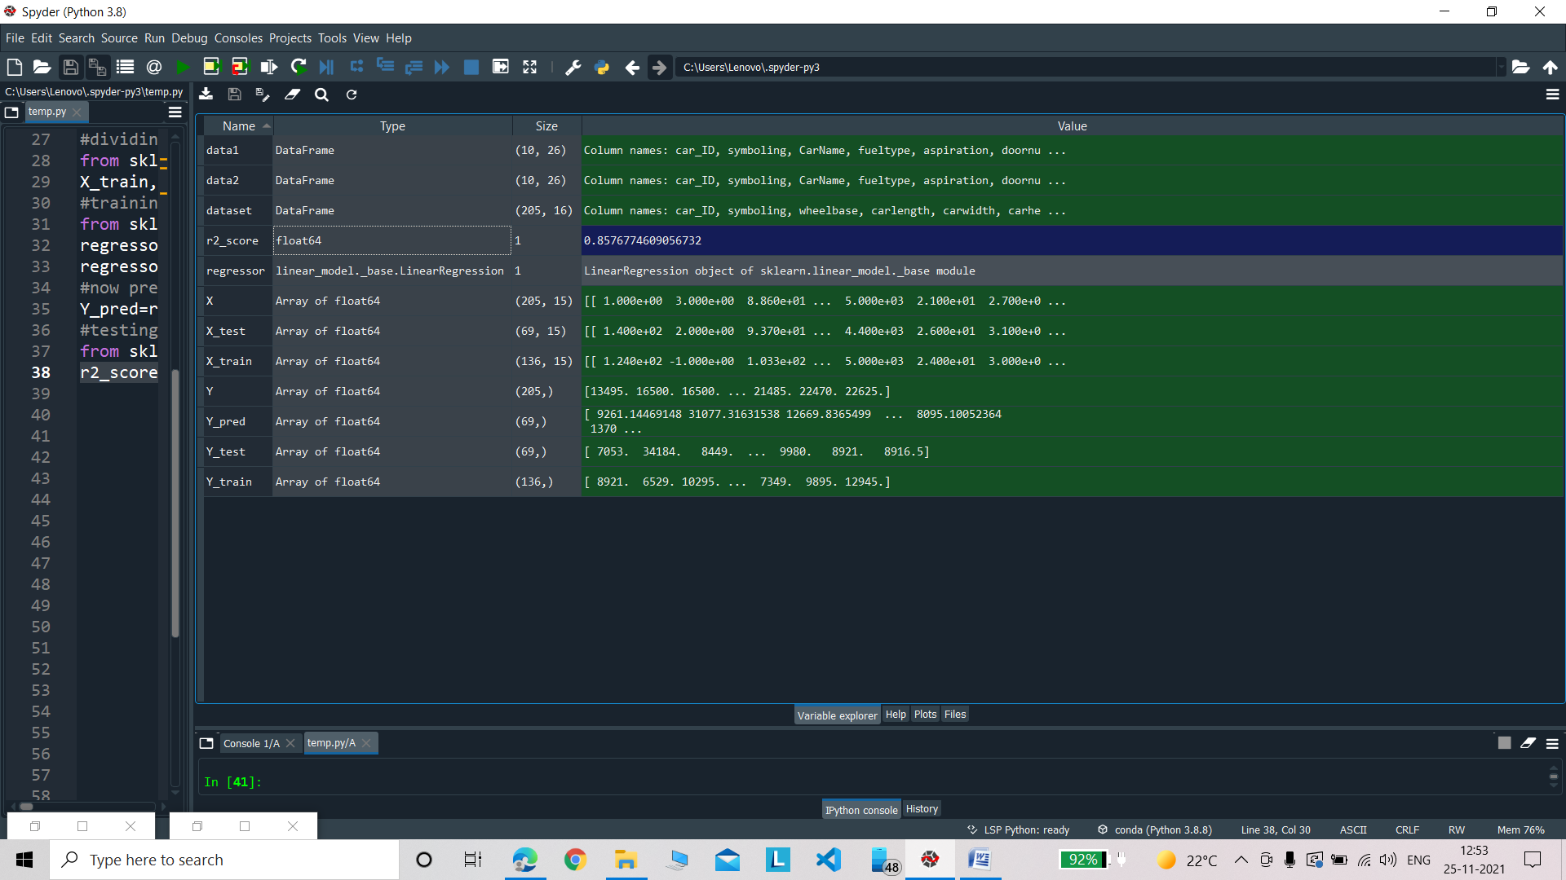

**R2_Score:**

The R2_Score of the model is 0.8576774609056732 hence our model is fairly accurate.